Assignment: Build Firefox

## Afia Fahmida Rahman

17101240

In this assignment, we were told to build Firefox on our personal computers. However, upon looking for necessary tools, I came to learn that there are specific requirements that the computer must fulfil before it may build the source code of firefox.

The requirements for the Windows build are as follows

* 64-bit version of Windows 7 or later
* About 40GB of free space on hard drive

The first step was the system requirements check. And since my computer fulfilled the criteria mentioned above, I went on to the next stage: downloading Visual Studio 2019, Community Edition.

We had to make sure that the following kits were included in our Visual Studio 2019:

* “Desktop development with C++” with the components “Windows 10 SDK” and “C++ ATL for v142 build tools (x86 and x64)”
* “Game development with C++”

The next step was to Build Mozilla from Visual Studio’s default main menu. Once I did, the following notifications showed up:

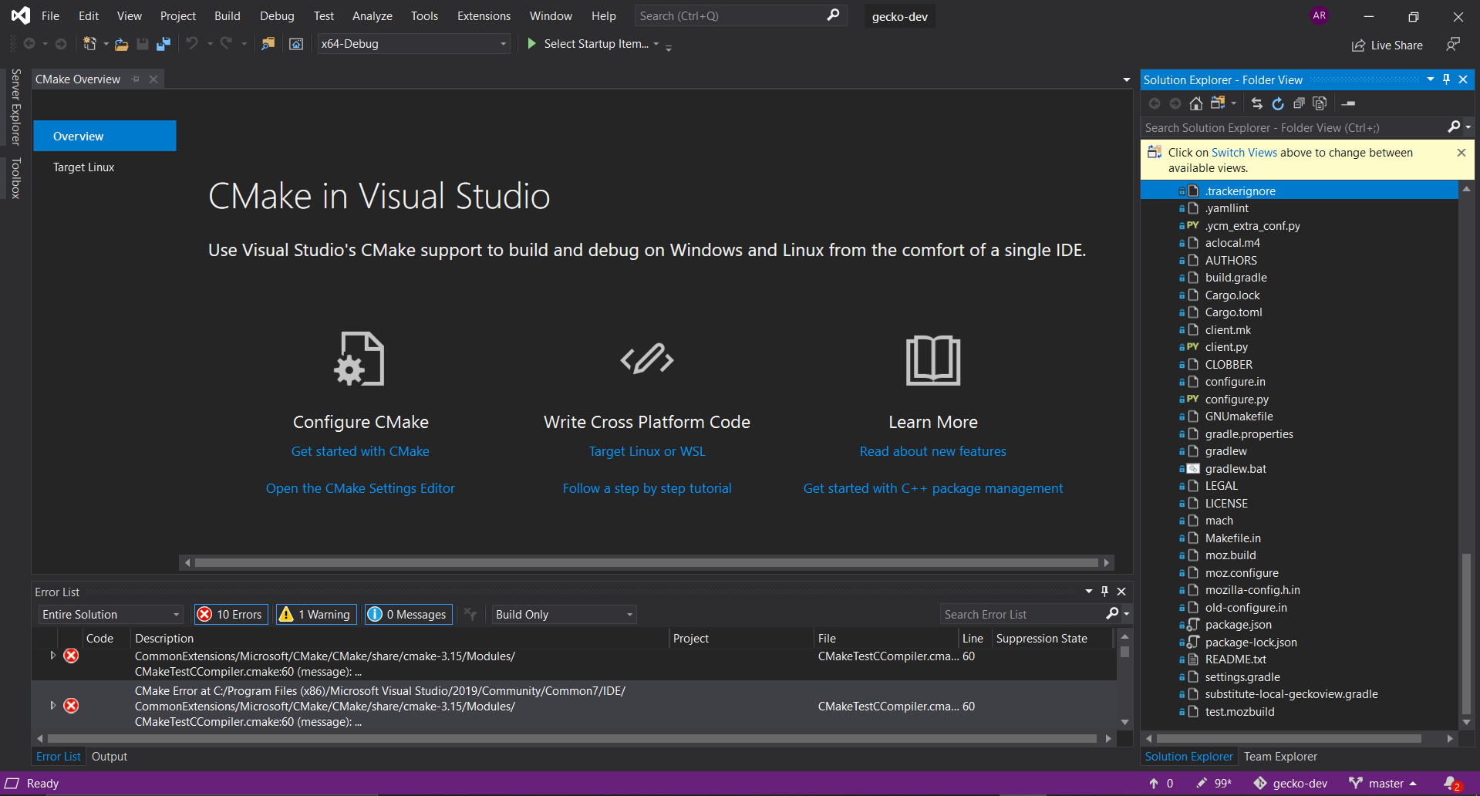

There were a total of 10 errors and 1 warning all on CMake.